Name:  Class: | ____________________________________  ________________ |  | Date: ___________
 | Year 11 Essential Mathematics Unit 2  SCORE:  / ___  Mini Test 2.6 2018  Topic – Time and timetables  Full working out MUST be shown to get full marks for each question.
Total Time: | 30 minutes
Weighting: | 1%
Equipment: | To be provided by the student: Pen, pencil, ruler, scientific calculator,1 single sided page of A4 notes

Question 1
Convert the following times below into different units. (6 marks)
- ¼ century into years

- 669 days into months

- 90 days into years

- 3.5 years into weeks
1 mark each
¼ x 100 = 25
3.5 x 52 = 182

- 367,200 seconds into days
669 /(365 ÷12) = 21.99 Or 669/30 = 22.3
367,200 /(60x 60x24) = 4.25

- 12,340 minutes into weeks
90 / 365 = 0.25
12340 / (60x24x7) = 1.22

Question 2
Complete the following table. (5 marks)

24 hour time | 12 hour time
0013 | 12:13am  1 mark each
1656 | 4:56 pm
0934 | 9:34am
2156 | 9:56pm
1216 | 12:16pm

Question 3
Marcus is looking forward to his favourite tv show which starts at 5:30pm. It is currently 2:55pm. How long does he need to wait? (2 marks)
1 mark for correct hours, 1 mark for correct minutes
1730 – 1455 = 2hrs 35mins

Question 4
Bradley is picking his 3 friends Steve, Marsha and Beryl to go to a restaurant. It will take 11 minutes to get from Bradley’s house to Steve’s, 7 minutes to get from Steve’s house to Marsha’s, 6 minutes to get from Marsha’s to Beryl’s and then 4 minutes to get from Beryl’s house to the restaurant. What time does Bradley need to leave home if the restaurant booking is for 7:30pm? (4 marks)

7:30 – 4mins = 7:26 7:26 – 6mins = 7:20 7:20 – 7mins = 7:13
1 mark for each correct
calculation

7:13 – 11mins = 7:02pm
Question 5 [7 marks: 1, 1, 2, 2 & 1 mark]

Mark needs to get from Roma Street Station in Brisbane to the Brisbane Domestic Airport as close to 1:30pm as he can. Below are two timetables - one for the train, the other for a bus:

Train timetable:

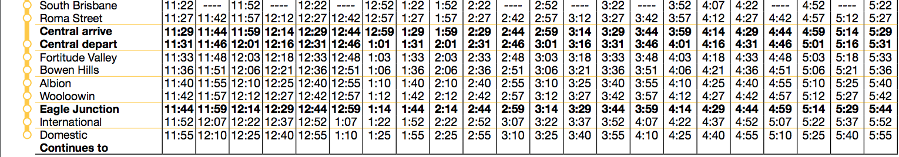

Bus timetable (Note: Brisbane Coach Terminal = Roma Street Station):

- What time would you need to depart Roma Street to arrive at the airport in time for the train?
1 mark – ½ if pm is missing
12:57pm

- What time would you need to depart Roma Street to arrive at the airport in time for the bus?
1 mark – ½ if pm is missing
12:50pm

- How long will it take you to travel to the airport via the train? Show working out
2 marks
1325-1257 = 28mins

- How long will it take you to travel to the airport via the bus? Show working out

1320-1250 = 30mins
2 marks

- Which method of transport was faster?

Train by 2mins
1 mark

Question 6 [6 marks: 1, 1, 1, 1, 2 marks]

Below is the tide chart for Fremantle from Monday 9th October to Sunday 15th October 2017, showing the 24-hour time and heights of low and high waters:

Use the tide chart to answer the following questions:

- On the tide chart, circle all the low tides, both time and heights.
1 mark

- How many high tides were there over the weekend?
Three times

- If you wanted to leave Fremantle by boat on a high tide on the morning of Sunday 15th, what was the earliest time you could leave?
0640
1 mark

- You were ready to come back onto land by 9pm on Sunday 15th, however you had to wait for a high tide. What was the earliest time you could bring the boat in?
9:55pm or 2155
1 mark

- How much time passed between the high tides on Sunday 15th October?
2155-0640 = 15hrs 15mins
2 marks

